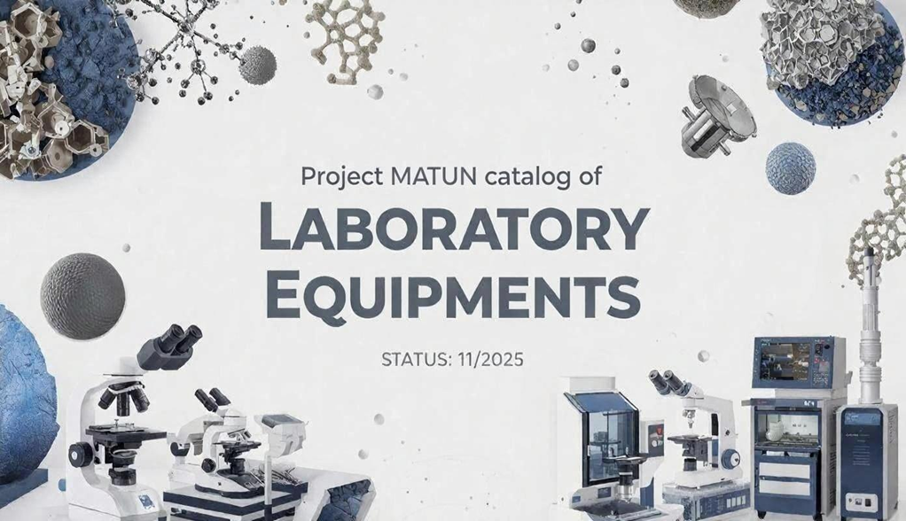
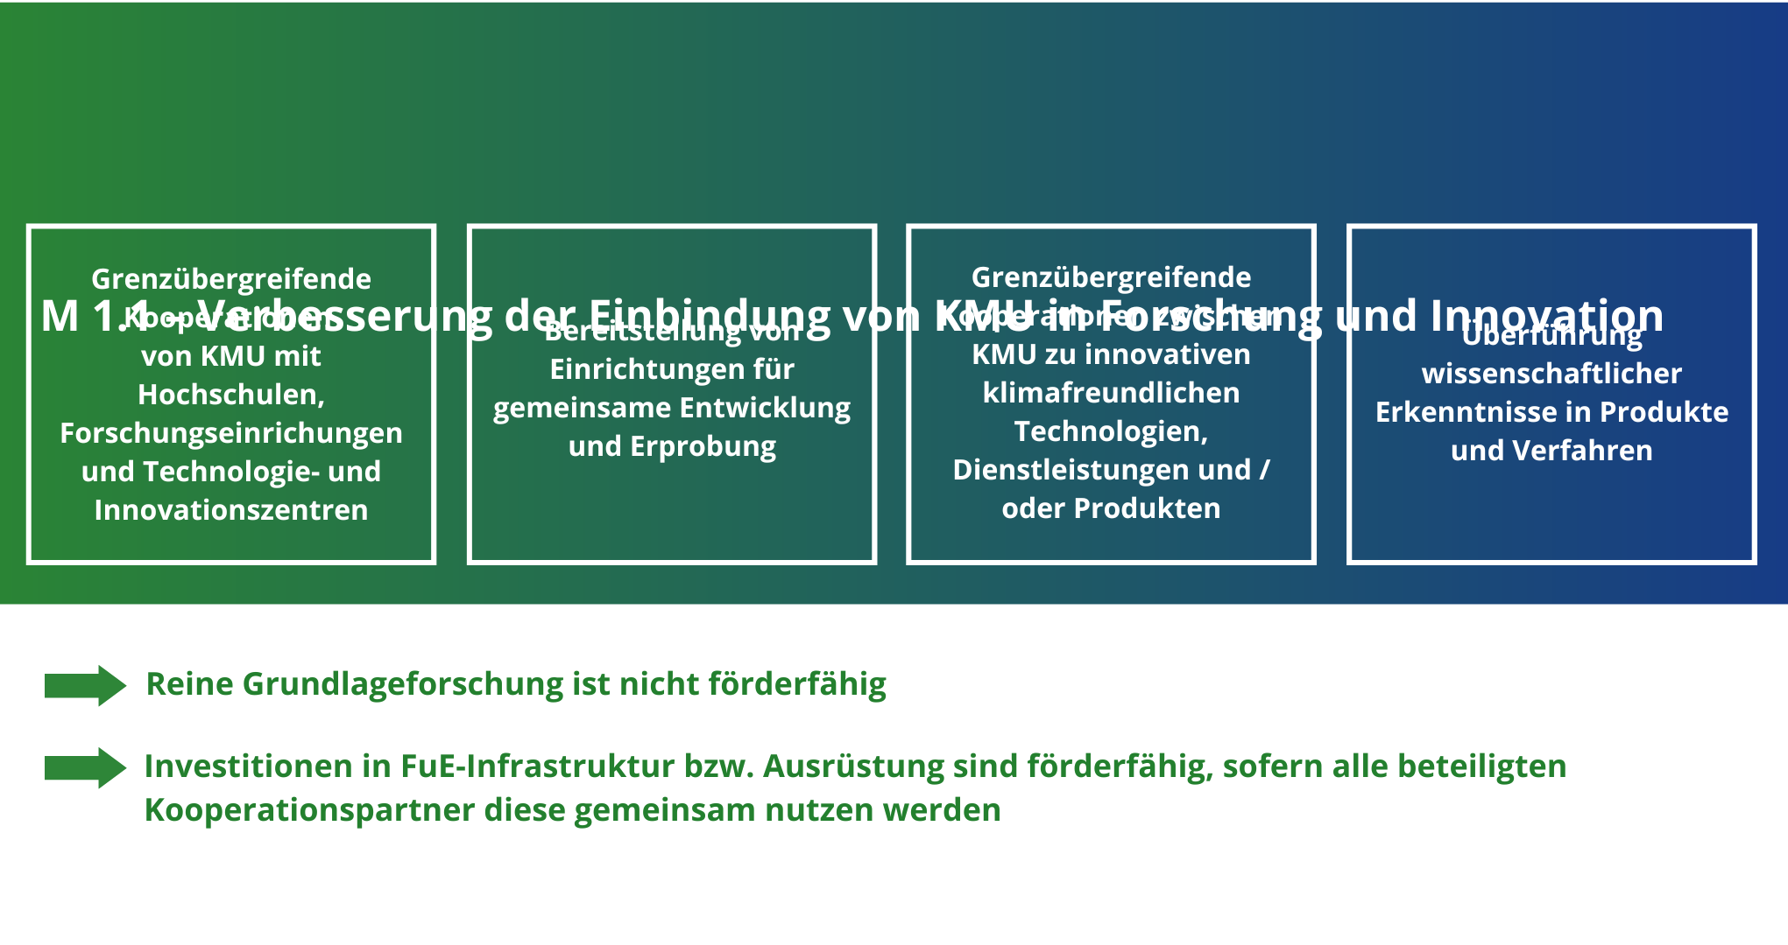
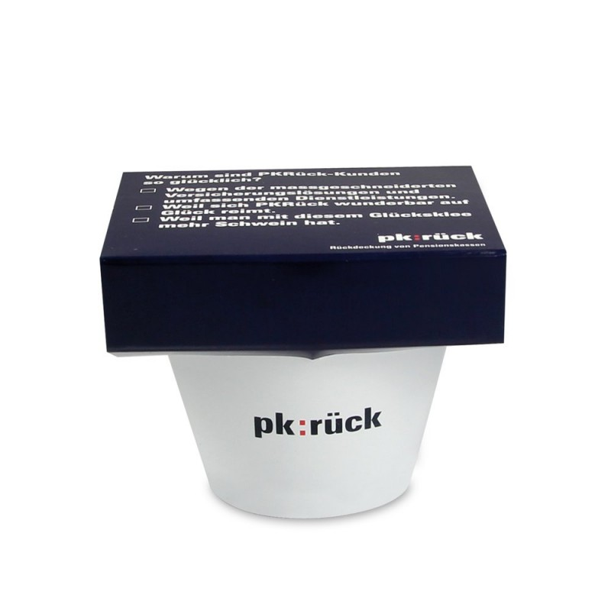





Für den Inhalt des Kataloges tragen die Projektpartner die Verantwortung.
Za obsah katalogu odpovídají projektoví partneři.

Der Katalog wurde im Rahmen des Projektes MATun MATERIALWISSEN – UNIS GEMEINSAM hergestellt.
Katalog byl vytvořen v rámci projektu MATUN SVĚT MATERIÁLŮ – UNIVERZITY SPOLU.


Gefördert durch/ Podporováno:
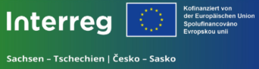

Teil der Prioritätsachse 3: Bildung, lebenslanges Lernen, Kultur und Tourismus
Část prioritní osy 3: Vzdělávání, celoživotní vzdělávání, kultura a cestovní ruch
Projektlaufzeit / Doba realizace projektu: 08.09.2023 – 31.12.2026
Projektnummer / Označení projektu: 100686706
Gesamtkosten des Projektes/ Celkové náklady projektu: 761.832,93 EUR
Fördersumme EU / Dotační prostředky EU: 609.466,34 EUR
WebSite: http://matun.trans3net.eu
Alle Rechte vorbehalten.
Všechna práva vyhrazena.
Content
(Laboratory) sieving machine 5
(Low-voltage) scanning electron microscope 6
Air permeability tester 7
Atomic force microscope 8
Atomic force microscope 9
Climate chamber 10
Confocals laser-scanning-microscop (cLSM) 11
Contact angle goniometer 12
Determination of freezing delais 13
Digital microscope 14
Drop shape analyser 15
Electrospinning device 16
Ellipsometer 17
Freeze-drying system 18
FT-IR spectrometer + UATR 19
Gas-material de/sorption tester 20
Ice adhesion test 21
LINKAM-cooling chambre 22
Micro-CT 23
MicroTester / MicroSquisher 24
Moisture analyzer 25
Muffle furnace 26
Nano-hardness meter 27
Nanotribometer 28
NMR spectroscopy 29
Plasma apparatus for powders 30
Plasma apparatus for thin film formation 31
Powder x-ray diffractometer 32
Precellyser 33
Scanning electron microscope (SEM) with tungsten cathode 34
Tensile strength analysis 35
Ultramicrotome 36
Universal testing machine 37
UniVert – Mechanical Test Machine 38
UV/VIS Spektroscop 39
Vibrating mill 40
Water permeability tester 41
X-ray diffractometer for thin films 42
X-ray fluorescence spectrometer 43
X-ray photocelectron spectroscopy 44

(Laboratory) sieving machine

Description
Screen sizes: 20 µm, 40 µm, 71 µm, 125 µm, 250 µm, 425 µm, 710 µm, each D = 100 mm, h = 40 mm

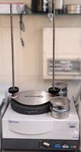
Technical Details
Výrobce / Hersteller: Retsch
Model / Modell: AS200

Contact Information
Location: TU Dresden
E-Mail: matun@tu-dresden.de

(Low-voltage) scanning electron microscope

Description
High-resolution low-voltage scanning electron microscope with field emission cathode Zeiss DSM 982 Gemini: resolution depends on sample, useful magnification: 100,000 - 200,000x, equipped with SE, SE-Inlens and BSE detector (Robinson detector), pixel resolutions of the images freely selectable by external image acquisition and beam control system DISS from Point-electronic, Noran-Voyager-3000-EDX system with Si(Li) detector

Technical Details
Výrobce / Hersteller: Carl Zeiss Microscopy GmbH
Model / Modell: DSM 982 Gemini

Contact Information
Location: TU Dresden
E-Mail: matun@tu-dresden.de

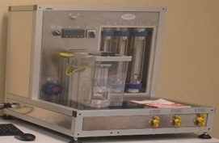
Air permeability tester

Description
Determination of air permeability of textiles and nanotextiles

Technical Details
Výrobce / Hersteller: Polymertest

Contact Information
Location: UJEP
Kontaktní osoba / Ansprechperson: Petr Ryšánek
E-Mail: matun@ujep.cz

Atomic force microscope

Description
-

Technical Details
Výrobce / Hersteller: Bruker
Model / Modell: Bioscope + Axiovert100M

Contact Information

Location: TU Dresden
Kontaktní osoba / Ansprechperson: Josephine Roth
E-Mail: matun@tu-dresden.de

Atomic force microscope

Description
Surface measurements by AFM (contact + intermittent contact)/ Lateral Force Microscopy / Magnetic Force Microscopy/ Electrostatic Force Microscopy / Scanning Capacitance Force Microscopy/ Kelvin Probe Force Microscopy / Piezoresponse Force Microscopy/ Spreading-Resistance Imaging / STM, samples up to 20 mm, range up to 3x3x2,6 um

Technical Details
Výrobce / Hersteller: NTMDT
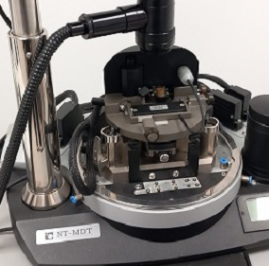
Model / Modell: Ntegra Aura

Contact Information
Location: UJEP
Kontaktní osoba / Ansprechperson: Martin Kormunda
E-Mail: matun@ujep.cz

Climate chamber

Description
-

Technical Details
Výrobce / Hersteller: Espec
Model / Modell: SH-221

Contact Information
Location: TU Dresden
Kontaktní osoba / Ansprechperson: Josephine Roth
E-Mail: matun@tu-dresden.de

Confocals laser-scanning-microscop (cLSM)

Description Contact Information
- High-resolution imaging of fluorescently labeled samples Location: TU Dresden
- Capable of optical sectioning for 3D reconstruction E-Mail: matun@tu-dresden.de

Technical Details
Výrobce / Hersteller: Carl Zeiss Microscopy GmbH
Model / Modell: LSM 510

Sample size/sample quantity:
- Designed for microscopic samples
- Suitable for cellular and subcellular imaging

Requirements for sample preparation:
- Samples should be appropriately fixed and stained with fluorescent markers
- Mounting on standard microscope slides with coverslips
- Ensure compatibility of fluorophores with the system's laser lines

Contact angle goniometer

Description
- Video-based optical contact angle measuring system for analyzing surface wettability and interfacial properties
- Utilizes high-performance 6x parfocal zoom lens with integrated continuous fine focus
- Suitable for static and dynamic contact angle measurements using sessile drop, captive bubble, and pendant drop methods
- Equipped with a high-resolution USB camera for precise drop shape analysis analyzing of contours and calculation of surface tensions and interfacial energies
Technical details Contact Information:
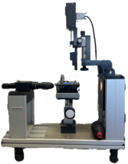
Výrobce / Hersteller: Dataphysics Location: TU Dresden
Model / Modell: OCA 20 Kontaktní osoba / Ansprechperson: Josephine Roth
Sample size/sample quantity: E-Mail: matun@tu-dresden.de
- Supports a wide range of sample sizes
Requirements for sample preparation:
- clean sample surface, free from contaminants
- appropriate liquid for contact angle measurement

Determination of freezing delais

Description
In this system, surfaces and paints can be tested for their freeze-delay effect. The system is designed for the automated gray value-controlled recording of the freezing temperature of 50 drops per temperature control cycle.

Technical Details
Výrobce / Hersteller: TU Dresden, IfWW
Model / Modell: Self-construction

Contact Information
Location: TU Dresden
Kontaktní osoba / Ansprechperson: Josephine Roth
E-Mail: matun@tu-dresden.de

Digital microscope

Description
Digital microscope with objective lens in range magnification 200-2000 times, used for optical analysis of materials and nanomaterials.
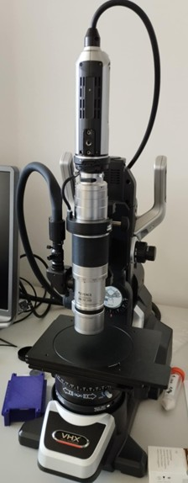
Technical Details
Výrobce / Hersteller: Keyence
Model / Modell: VHX

Contact Information
Location: UJEP
Kontaktní osoba / Ansprechperson: Petr Ryšánek
E-Mail: matun@ujep.cz

Drop shape analyser

Description
Analysis of wetting and adhesion, determination of contact angle and surface tension

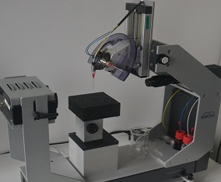
Technical Details
-

Contact Information
Location: UJEP
Kontaktní osoba / Ansprechperson: Martin Kormunda
E-Mail: matun@ujep.cz

Electrospinning device

Description
Preparation of nanofibrous textiles based on electrospinning, both from a needle and in a needleless arrangement
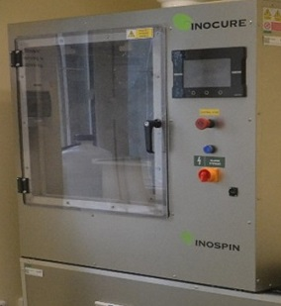
Technical Details
Výrobce / Hersteller: Inocure
Model / Modell: InoSPIN mini

Contact Information
Location: UJEP
Kontaktní osoba / Ansprechperson: Petr Ryšánek
E-Mail: matun@ujep.cz

Ellipsometer

Description
Spectroscopic 190 - 2100 nm, automated VASE 40o-90o, automated XY stage diameter 200 mm,
selectable footprint 0.05 mm to 1 mm

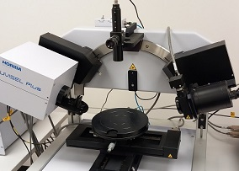
Technical Details
Výrobce / Hersteller: Horiba
Model / Modell: UVISEL Plus

Contact Information
Location: UJEP
Kontaktní osoba / Ansprechperson: Martin Kormunda
E-Mail: matun@ujep.cz

Freeze-drying system

Description Contact Information
- Compact high-performance laboratory freeze-dryer Location: TU Dresden
- Suitable for vials, ampoules, and tubes Kontaktní osoba / Ansprechperson: Josephine Roth
- Ideal for pharmaceutical and solvent-containing samples E-Mail: matun@tu-dresden.de

Technical Details
Výrobce / Hersteller: Perkin Elmer
Model / Modell: Spectrum Two + UATR-Einheit
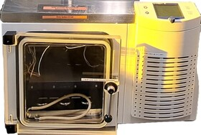
Sample size/sample quantity:
- Designed to accommodate small sample sizes
- Suitable for analyzing microgram quantities
Requirements for sample preparation:
- Place samples in vials or ampoules
- Ensure compatibility with freeze-drying
- Do not exceed unit capacity
- Proper sealing required for sample integrity

FT-IR spectrometer + UATR

Description:
- Fourier Transform Infrared (FT-IR) Spectrometer with Universal Attenuated Total Reflectance (UATR) accessory
- Enables rapid, non-destructive analysis of a wide range of samples, including solids, liquids, and pastes
- Suitable for applications in pharmaceuticals, polymers, and academia

Technical Details Contact Information
Výrobce / Hersteller: Perkin Elmer Location: TU Dresden
Model / Modell: Spectrum Two + UATR-Einheit Kontaktní osoba / Ansprechperson: Josephine Roth
Sample size/sample quantity: E-Mail: matun@tu-dresden.de
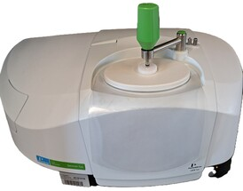
- Designed to accommodate small sample sizes
- Suitable for analyzing microgram quantities
Requirements for sample preparation:
Minimal preparation required
- For solids: place directly on the UATR crystal
- For liquids: apply a drop onto the crystal

Gas-material de/sorption tester

Description
Application of the Dynamic gas chromatography and Pressure decay methods for complex determination of sorption and desorption properties, catalytic activity especially of flexible materials (textiles) in interaction with these gases and vapors (H₂, D₂, N₂, Noble gases, CO, CO₂, SO₃, Air, Alkanes, Alkenes, Alkynes, Hydrocarbon Halogen Derivatives).

Technical Details
Výrobce / Hersteller: SVCS + UJEP
Model / Modell: prototype

Contact Information
Location: UJEP
Kontaktní osoba / Ansprechperson: Václav Šícha
E-Mail: matun@ujep.cz

Ice adhesion test

Description
The ice adhesion tester is a special design from the mechanical-technical laboratory of the Institute of Materials Science. It is a horizontally arranged shear test. It determines the shear stress required to detach a frozen ice puck under quasi-static load. With one cooling cycle, 10 samples can be tested in succession

Technical Details
Výrobce / Hersteller: TU Dresden, IfWW – using an ESPEC-Kammer SH242
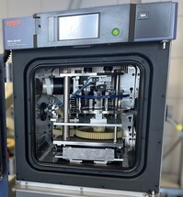
Model / Modell: Self-construction

Contact Information
Location: TU Dresden
Kontaktní osoba / Ansprechperson: Josephine Roth
E-Mail: matun@tu-dresden.de

LINKAM-cooling chambre

Description
- Enables controlled heating and cooling of samples
- Observation of crystallization processes, temperature-dependent structural changes, temperature-influenced mechanical experiments and similar
- Temperature range of -40 to + 150°C
Technical Details
Výrobce / Hersteller: Linkam Scientific Instruments Ltd.
Model / Modell: THMS 600, LTD 350
Contact Information
Location: TU Dresden
Kontaktní osoba / Ansprechperson: Josephine Roth
E-Mail: josephine.roth@tu-dresden.de

Micro-CT

Description Contact Information
- In-vivo high-resolution Micro-CT scanner for small animals Location: TU Dresden
- Enables non-invasive 3D imaging E-Mail: matun@tu-dresden.de
- Low X-ray dose for longitudinal studies
- Large field of view for full-body scan

Technical Details
Sample size/sample quantity: Výrobce / Hersteller: SancoMedical
Designed for small animals (mice, rats) Model / Modell: vivaCT 75
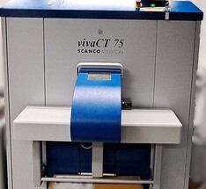
- Capable of whole-body imaging
- Suitable for longitudinal studies

Requirements for sample preparation
- Minimal preparation required
- Light sedation or anesthesia
to prevent movement

MicroTester / MicroSquisher

Description
- Micro-scale mechanical test system for high-precision material testing
- Designed for small specimens with superior force resolution
- Enables easy test setups with real-time visual monitoring
- Suitable for small tissue samples, hydrogel microspheres, cell spheroids, and engineered microtissue

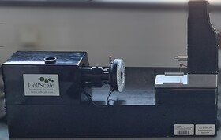
Technical Details
Výrobce / Hersteller: Cell Scale
Model / Modell: MicroTester
Contact Information
Location: TU Dresden
E-Mail: matun@tu-dresden.de

Moisture analyzer

Description
Laboratory instrument for measuring relative moisture content in various materials

Technical Details
Výrobce / Hersteller: Radwag
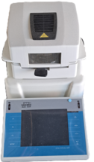
Model / Modell: Feuchtebestimmer MA 60.3Y
Sample size/sample quantity: Maximum sample weight: 60 g

Contact Information
Location: TU Dresden
E-Mail: matun@tu-dresden.de

Muffle furnace

Description
High-temperature furnace for heat treatment processes
Suitable for annealing, tempering, and hardening of materials
Technical Details
Výrobce / Hersteller: Paddelttherm
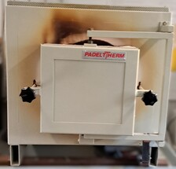
Model / Modell: TC 405/20
Sample size/sample quantity:
Chamber size: 400 mm width × 500 mm depth × 200 mm height
Suitable for medium-sized samples

Contact Information
Location: TU Dresden
E-Mail: matun@tu-dresden.de

Nano-hardness meter

Description
High sensitivity (75 nN, 0.2 nm), accuracy and reliability.
The ultra-sensitive xProbe transducer can then offer nanoindentation with near AFM parameters.
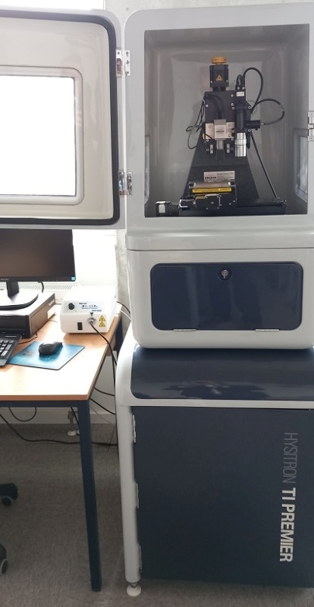
Technical Details
Výrobce / Hersteller: Hysitron
Model / Modell: TI Premier
Contact Information
Location: UJEP
Kontaktní osoba / Ansprechperson: Martin Kormunda
E-Mail: matun@ujep.cz

Nanotribometer

Description
- Pin-on-disk design
- temperature chamber up to 400 °C
- can be measured with or without lubrication
- load below 1N
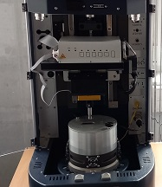
Technical Details
Výrobce / Hersteller: Bruker UMT
Model / Modell: Tribolab
Contact Information
Location: UJEP
Kontaktní osoba / Ansprechperson: Martin Kormunda
E-Mail: matun@ujep.cz

NMR spectroscopy

Description
Samples in the magnetic field are irradiated with short radio waves, the response of nuclei can determine the composition and structure of molecules, for solutions and solids.

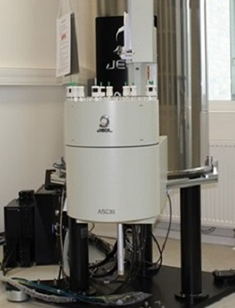
Technical Details
Výrobce / Hersteller: JEOL
Model / Modell: JNM-ECZ400R/M1

Contact Information
Kontaktní osoba / Ansprechperson: Václav Šícha
E-Mail: matun@ujep.cz

Plasma apparatus for powders

Description
Variable system for plasma surface treatment of casing and bulk materials under low pressure.

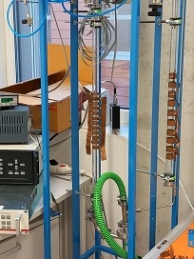
Technical Details
Výrobce / Hersteller: UJEP

Contact Information
Location: UJEP
Kontaktní osoba / Ansprechperson: Martin Kormunda
E-Mail: matun@ujep.cz

Plasma apparatus for thin film formation

Description
Universal system for deposition of thin films by magnetron sputtering supplemented by plasma polymerization capabilities.

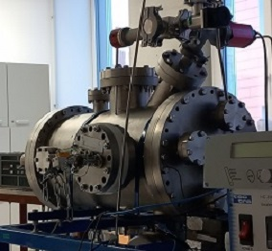
Technical Details
Výrobce / Hersteller: UJEP

Contact Information
Location: UJEP
Kontaktní osoba / Ansprechperson: Martin Kormunda
E-Mail: matun@ujep.cz

Powder x-ray diffractometer

Description
X-ray diffractometer for studying the structure of substances; position-sensitive detector or proportional detector available; Anton Paar HTK 1200N high-temperature chamber (up to 1200oC) can be used; samples can also be measured in a capillary or in transmission geometry

Technical Details
Výrobce / Hersteller: Malvern Panalytical
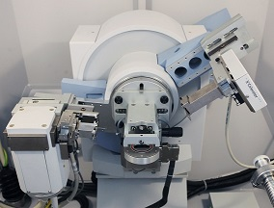
Model / Modell: X’Pert MPD Pro

Contact Information
Location: UJEP
Kontaktní osoba / Ansprechperson: Petr Ryšánek
E-Mail: matun@ujep.cz

Precellyser

Description Contact Information
- High-throughput tissue homogenizer Location: TU Dresden
- Capable of processing up to 24 samples simultaneously E-Mail: matun@tu-dresden.de
- Suitable for various biological samples, including
animal and plant tissues, as well as microorganisms

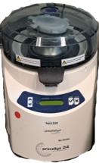
Technical Details
Výrobce / Hersteller: Bertin Technologies
Model / Modell: Precellyser 24

Sample size/sample quantity:
- Accommodates 1 to 24 tubes of 2 mL or 0.5 mL
- Speed range from 4,500 rpm to 6,800 rpm,
adjustable in 100 rpm increments

Requirements for sample preparation
- Load samples into appropriate tubes

Scanning electron microscope (SEM) with tungsten cathode

Description
Resolution: sample-dependent, approx. 10 nm at 20 kV, useful magnification: 20,000x - 30,000x, Standard SE detector and 3d BSE detector (Point-electronic) with MeX software (Alicona), 3d reconstructions of the surface, roughness measurements, pixel resolutions of the images freely selectable via external image acquisition and beam control system DISS from Point-electronic, Noran system 7 -EDX system with SDD detector
Technical Details
Výrobce / Hersteller: Carl Zeiss Microscopy GmbH
Model / Modell: DSM 950
Contact Information
Location: TU Dresden
E-Mail: matun@tu-dresden.de

Tensile strength analysis

Description
Determination of tensile strength for polymers, non-ferrous metals, nanofibrous materials

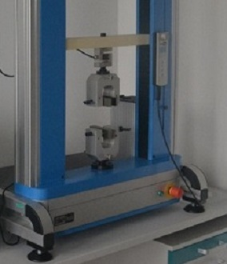
Technical Details
Výrobce / Hersteller: Labortech
Model / Modell: LabTest 6.050

Contact Information
Location: UJEP
Kontaktní osoba / Ansprechperson: Petr Ryšánek
E-Mail: matun@ujep.cz

Ultramicrotome

Description Contact Information
- Precision ultramicrotome for ultrathin sectioning Location: TU Dresden
of biological and material science samples E-Mail: matun@tu-dresden.de
- Designed for TEM, SEM, and AFM sample preparation
- Adjustable cutting window and speed settings
- Compatible with biological tissues, polymers, and hard materials
Technical Details
Výrobce / Hersteller: Leica
Model / Modell: EM UC6
Sample size/sample quantity:
- supports a wide range of sample sizes
Requirements for sample preparation:
- Specimens must be embedded in resin (e.g., epoxy or acrylic)

Universal testing machine

Description
Electromechanical testing system with a capacity of 10 kN
Versatile for tensile, compression, flexural, and other mechanical tests
Load range: 100 N to 10 kN
Speed range: 0.005 to 500 mm/min
Temperature range: -70 to 350°C
Technical Details
Výrobce / Hersteller: Instron
Model / Modell: 5566
Sample size/sample quantity:
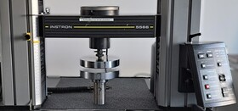
- Accommodates various sample sizes
- Specific dimensions depend on material and test standards
Contact Information
Location: TU Dresden
E-Mail: matun@tu-dresden.de

UniVert – Mechanical Test Machine

Description Contact Information
- Compact and flexible universal testing machine for biomaterials Location: TU Dresden
- Designed for precise mechanical analysis of biological tissues, E-Mail: matun@tu-dresden.de
3D bio-printed structures, and medical devices
- Small footprint ideal for laboratory environments
- Provides high-precision force measurements
and controlled loading conditions
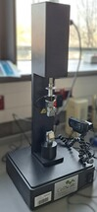
- Supports force capacities from 0.05 N to 10,000 N
Standard speed range up to 20 mm/s
Technical Details
Výrobce / Hersteller: Cell Scale
Sample size/sample quantity:
- Adjustable grips and fixtures for diverse sample types
Requirements for sample preparation:
- Specific cutting of the samples

UV/VIS Spektroscop

Description:
-

Technical Details
Výrobce / Hersteller: TECAN
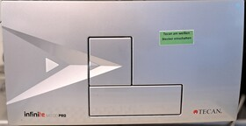

Contact Information
Location: TU Dresden
E-Mail: matun@tu-dresden.de

Vibrating mill
Description Contact Information
- Compact, versatile benchtop unit for dry, wet, and cryogenic grinding Location: TU Dresden
- Ideal for homogenizing small sample volumes E-Mail: matun@tu-dresden.de
- Suitable for biological samples, minerals, tablets, and plastics
- Capable of grinding, mixing, homogenization, cell disruption, and cryogenic grinding
- Compatible with passive cooling using liquid nitrogen (LN₂)
- Adjustable vibrational frequency from 3 Hz to 30 Hz (180 min⁻¹ to 1800 min⁻¹)
- Typical grinding time ranges from 30 seconds to 2 minutes
- Suitable for hard, medium-hard, soft, brittle, elastic, and fibrous materials
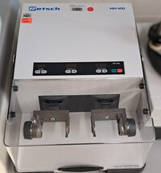
Technical Details
Výrobce / Hersteller: Retsch
Model / Modell: MM 400
Sample size/sample quantity:
- Standard grinding jars: 50 ml and 35 ml stainless steel
Requirements for sample preparation
- Ensure samples are appropriately sized (≤8 mm) for the grinding process

Water permeability tester

Description
Determination of water permeability of textiles and nanotextiles, water column analysis

Technical Details
Výrobce / Hersteller: Polymertest

Contact Information
Location: UJEP
Kontaktní osoba / Ansprechperson: Petr Ryšánek
E-Mail: matun@ujep.cz

X-ray diffractometer for thin films

Description
X-ray diffractometer for the study of thin layers (X-ray diffraction, X-ray reflectivity), or elastic stress analysis

Technical Details
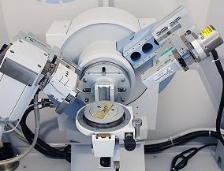
Výrobce / Hersteller: Malvern Panalytical
Model / Modell: X’Pert MPD Pro

Contact Information
Location: UJEP
Kontaktní osoba / Ansprechperson: Petr Ryšánek
E-Mail: matun@ujep.cz

X-ray fluorescence spectrometer

Description
X-ray fluorescence spectrometer for standardless elemental analysis (C-U), surface mapping with 0.2mm2 resolution, automatic feeder for 12 samples

Technical Details
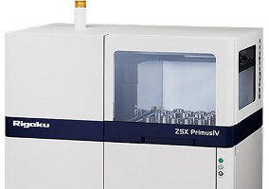
Výrobce / Hersteller: Rigaku
Model / Modell: ZSX Primus IV

Contact Information
Kontaktní osoba / Ansprechperson: Petr Ryšánek
E-Mail: matun@ujep.cz

X-ray photocelectron spectroscopy

Description
Surface-sensitive technique to determine the elemental composition of the surface, the representation of elements and their bond

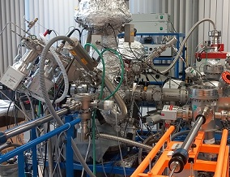
Technical Details
-

Contact Information
Location: UJEP
Kontaktní osoba / Ansprechperson: Martin Kormunda
E-Mail: matun@ujep.cz

Contact

J. E. Purkyně University in Ústí nad Labem TU Dresden
Faculty of Science Faculty of Mechanical Engineering
40096 Ústí nad Labem 01062 Dresden
matun@ujep.cz matun@tu-dresden.de

Ing. Petr Lauterbach, petr.lauterbach@ujep.cz Dr.-Ing. Ute Bergmann, Ute.Bergmann@tu-dresden.de
Bc. Zuzana Fridrichová, zuzana.fridrichova@ujep.cz Josephine Roth, Josephine.Roth@tu-dresden.de
Gritt Ott, Gritt.Ott@tu-dresden.de
Carolin Böhme, Carolin.Boehme@tu-dresden.de

To get more information please follow the link: https://trans3net.eu/?page_id=5398

